*using the internet where you work, during working hours, for activities that are not related to work*  
Cyberloafing results in lost productivity and could even land companies in legal hot water.



|  |
| --- |
| **D** |

|  |
| --- |
| **daisy** |

Daisies are attractive flowers, often associated with innocence and purity. They may seem the simplest flowers in the world, but there are many interesting things that set these flowers apart. They’re great for a game of s/he loves me, s/he loves me not. If you’re ever in doubt about the nature of your relationship, you can just pluck the petals of a daisy one by one, alternating, s/he loves me with s/he loves me not. When you pluck the last petal, you have your answer. And hey, if you don’t like the first answer, you can try again with another daisy.



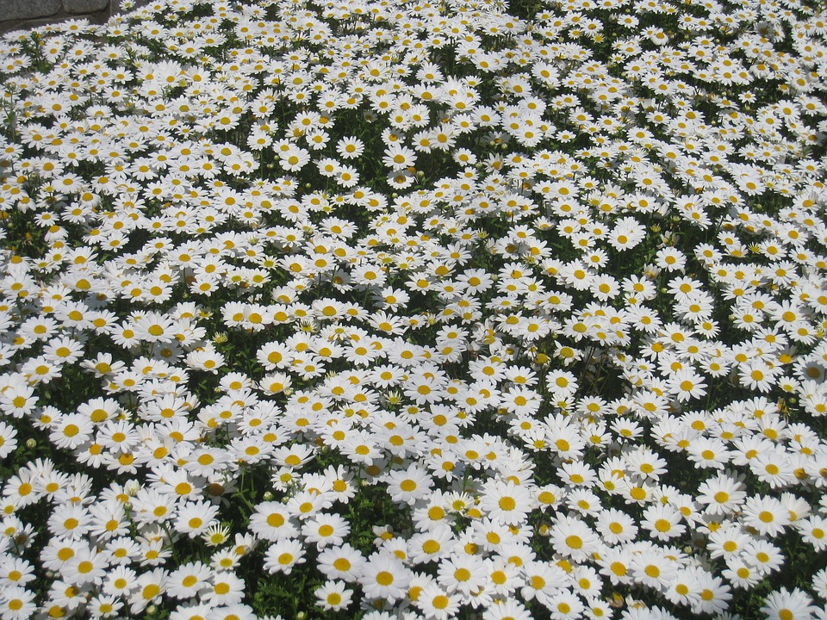

|  |
| --- |
| **death** |

The disease causes thousands of deaths a year.  
Do you believe in life after death?  
He never got over the death of his daughter.  
The failure of the family business was the death of him.  
That child will be the death of me (= is always doing something which upsets me)!

|  |
| --- |
| **deceased** |

The deceased shot her mother before killing herself.  
Five of the deceased were employed by the club.

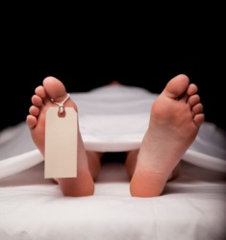

|  |
| --- |
| **decline** |

His interest in the project declined after his wife died.  
The party's popularity has declined in the opinion polls.  
The higher prices caused a sharp decline in sales.  
The last three years have seen a dramatic decline in the number of tigers in the area.  
Her health has been declining progressively for several months.

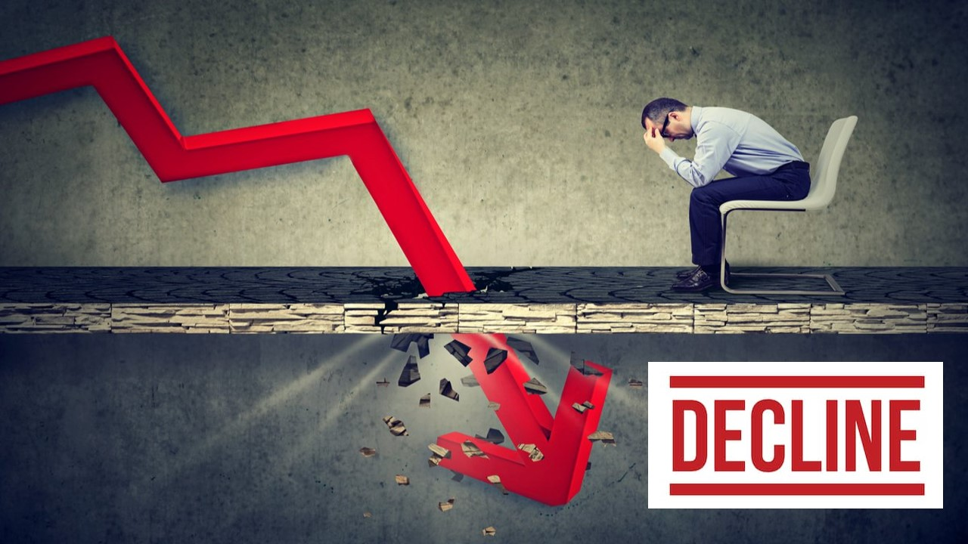

|  |
| --- |
| **denounce** |

*to criticize something or someone strongly and publicly:*  
The government's economic policy has been denounced on all sides.  
We must denounce injustice and oppression.  
The teachers denounced the contract offer as inadequate.

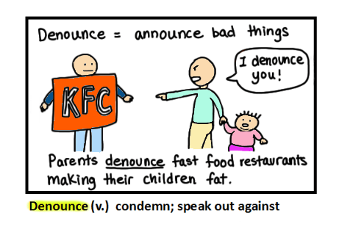

|  |
| --- |
| **dense** |

Their helicopter could not land because of the dense jungle.  
The land around here is covered with dense vegetation.  
Britain has a particular problem because of dense population.  
They had to clear a road through an area of dense forest.

[caption id="attachment_10734" align="alignnone" width="1300"]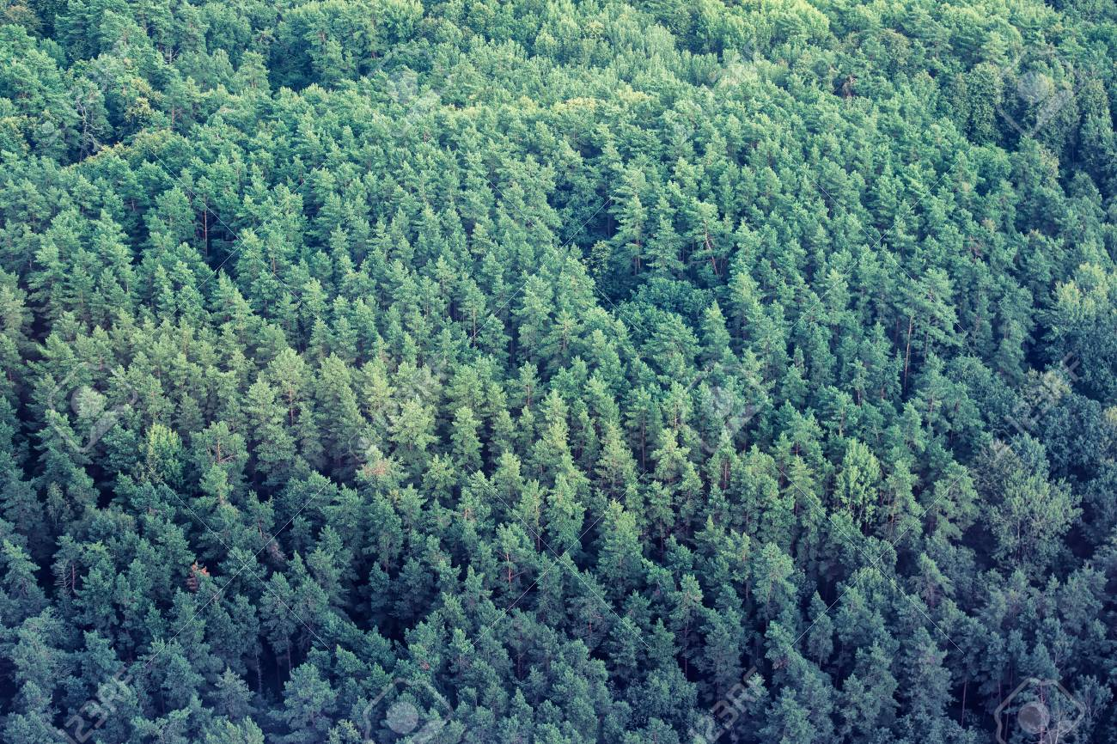 Aerial view of dense forest. Background with evergreen trees.[/caption]

|  |
| --- |
| **deport** |

***to make someone leave a country and return to the country they came from, especially because they do not have a legal right to stay***  
He was deported from Ecuador when his visa expired.  
Two foreign journalists who reported the protests were deported.  
Thousands of illegal immigrants are caught and deported every year.  
The refugees were deported back to their country of origin.



|  |
| --- |
| **deportation** |

***the action of forcing someone to leave a country, especially someone who has no legal right to be there or who has broken the law:***  
There were mass deportations in the 1930s, when thousands of people were forced to leave the country.  
Their cases will be reviewed and they may face deportation.

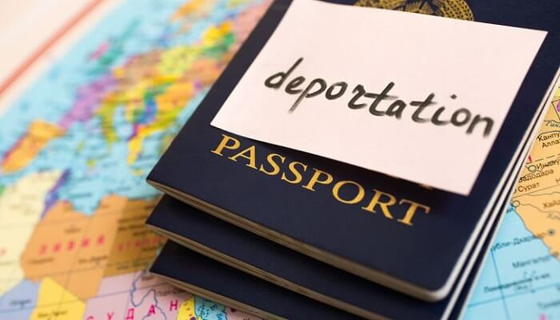

|  |
| --- |
| **dermatology** |

**the scientific study of the skin and its diseases**



|  |
| --- |
| **despise** |

***to dislike and have a low opinion of someone or something***  
She despised her neighbours.  
I felt that the other kids despised me for having the wrong accent and the wrong colour skin.  
We were brought up to despise the people from the poor side of town. They seemed so dirty and ignorant.

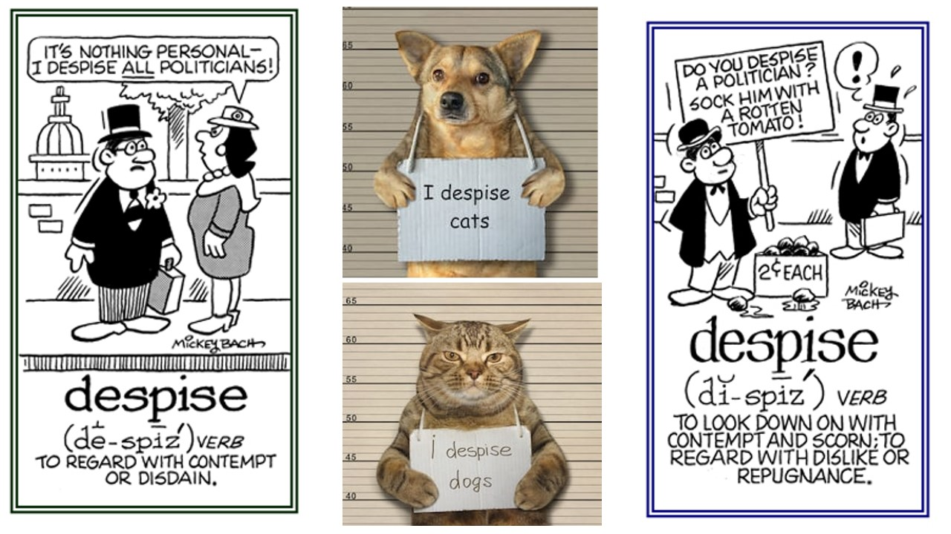

|  |
| --- |
| **detect** |

**to notice something that is partly hidden or not clear, or to discover something, especially using a special method:**  
Radar equipment is used to detect (= find the position of) enemy aircraft.  
Some sounds cannot be detected by the human ear.  
Financial experts have detected signs that the economy is beginning to improve.

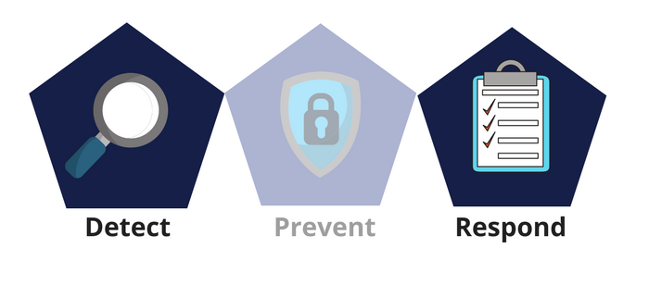

|  |
| --- |
| **detrimental** |

***causing harm or damage:***  
These chemicals have a detrimental effect/impact on the environment.  
Their decision could be detrimental to the future of the company.

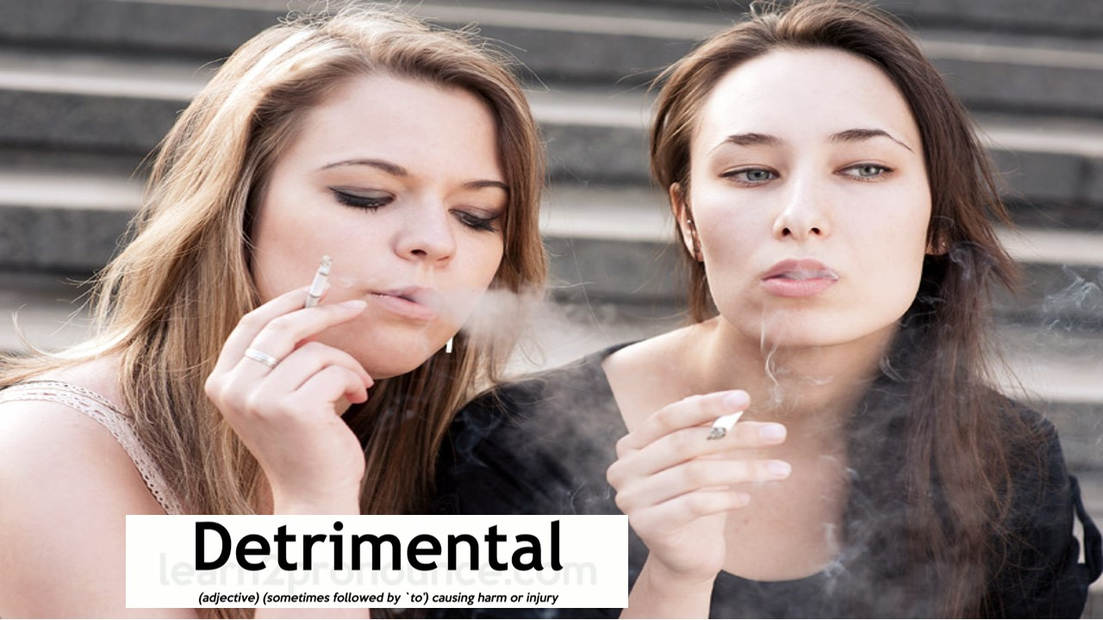

|  |
| --- |
| **devastating** |

Acid rain has a devastating effect on the forest.  
The recession has had a devastating impact on employment in this area.  
The party suffered a devastating defeat in the local election.  
All had suffered devastating effects from the war.

[caption id="attachment_10508" align="alignnone" width="1024"]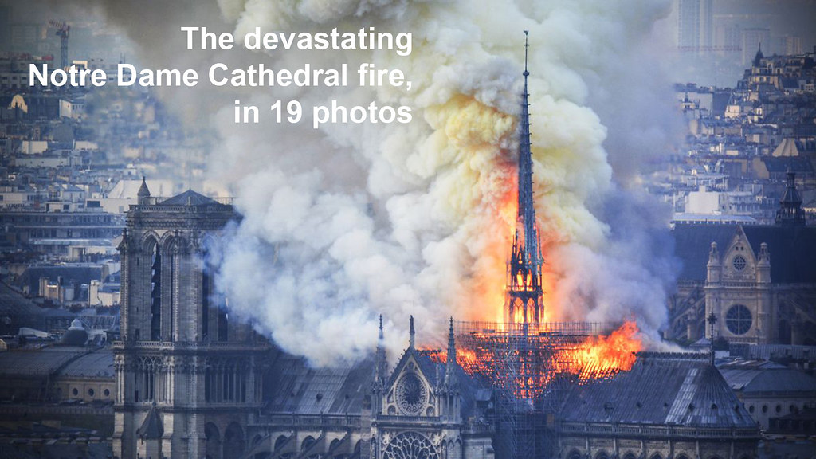 The devastating Notre Dame Cathedral fire, in 19 photos https://www.vox.com/world/2019/4/15/18311852/notre-dame-cathedral-fire-spire-collapse-photos-pictures-paris-france[/caption]

|  |
| --- |
| **device** |

The shops are always full of new electronic devices.  
One day it will be technically possible to replace patients’ hearts with mechanical devices.  
The company makes devices to detect carbon monoxide.

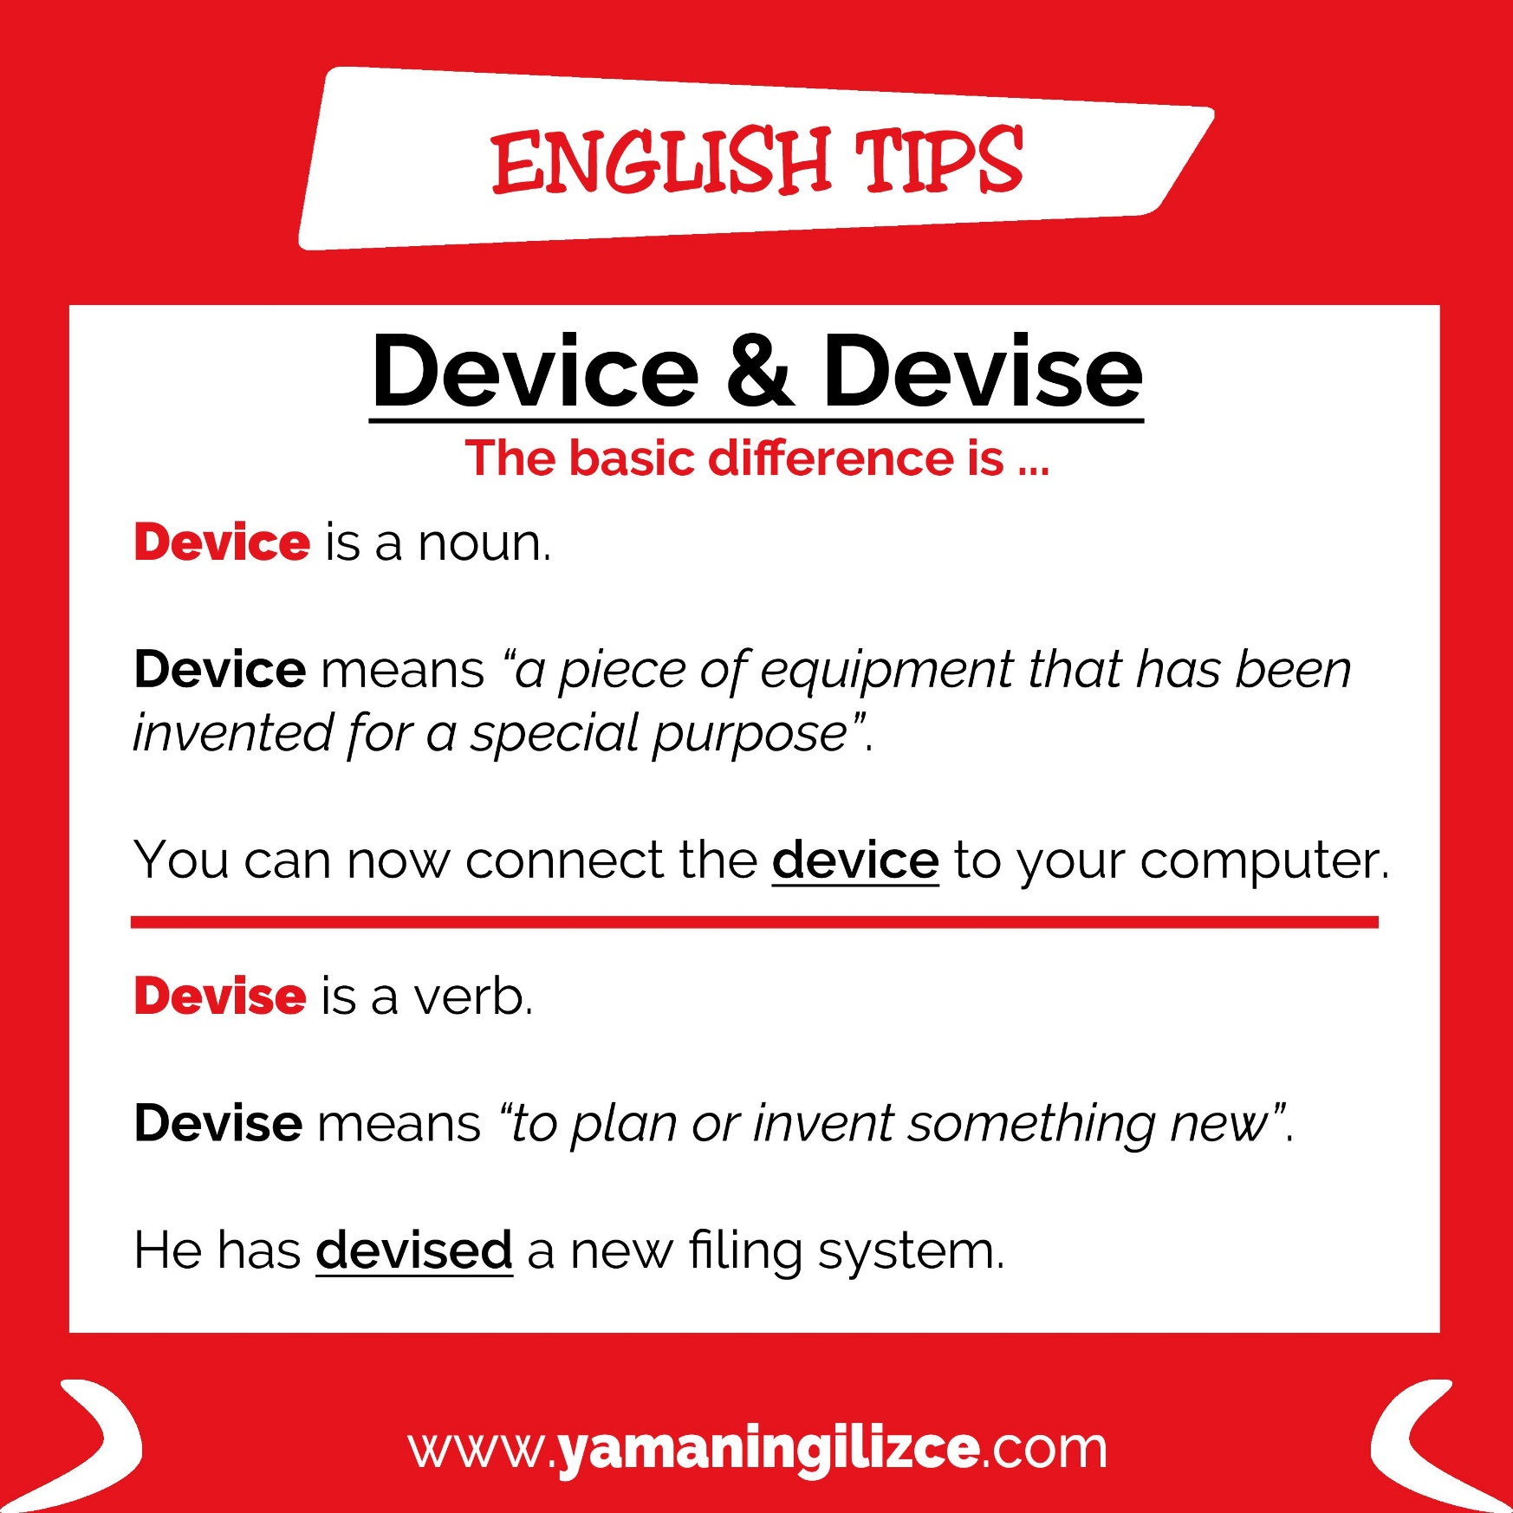

|  |
| --- |
| **devise** |

She devised a method for quicker communications between offices.  
Our aim is to devise a way to improve quality and reduce costs.  
He's good at devising language games that you can play with students in class.  
He devised a new way to treat mental depression.

|  |
| --- |
| **diagnose** |

His condition was diagnosed as some type of blood disorder.  
She was diagnosed with/as having diabetes.  
Joe struggled in school before he was diagnosed as dyslexic.  
She was diagnosed with breast cancer.

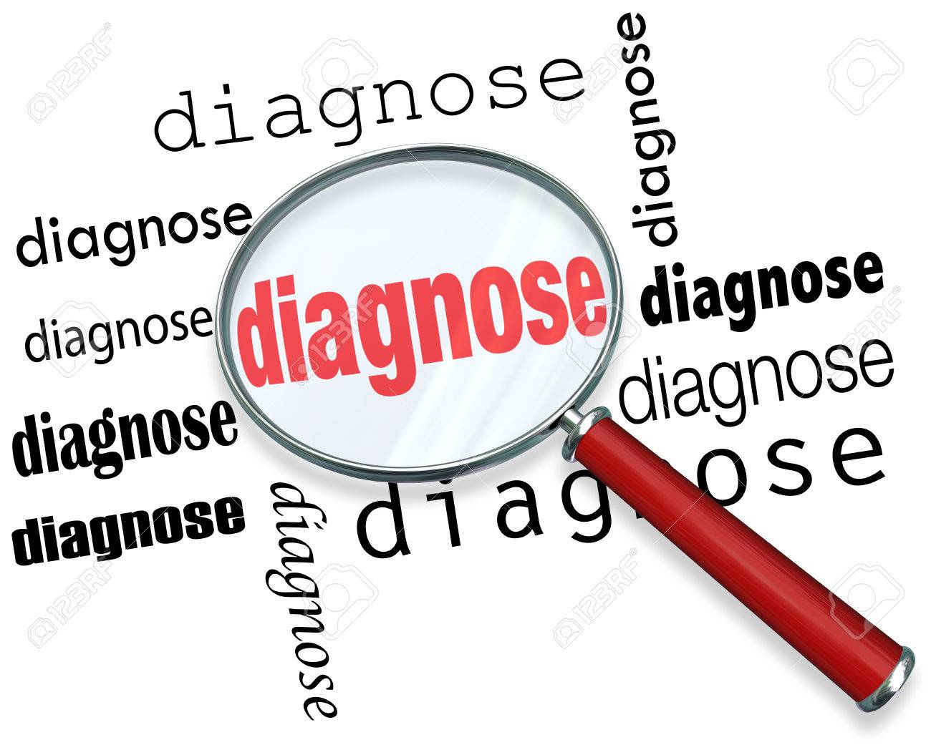

|  |
| --- |
| **discharge** |

*to allow someone officially to leave somewhere, especially a hospital or a law court:*  
Patients were discharged from the hospital because the beds were needed by other people.  
More than half of all prisoners discharged are reconvicted within two years.  
UK A peace protester was conditionally discharged for twelve months (= allowed to go free only if they do not commit a crime again for this period of time).

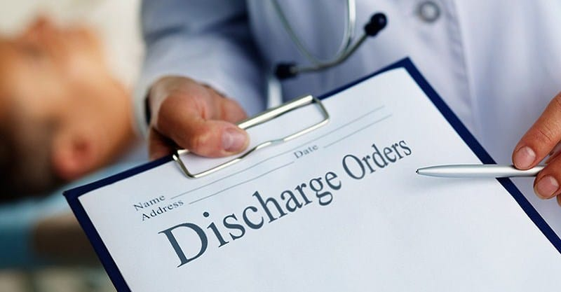

|  |
| --- |
| **discriminate** |

Newborn babies can discriminate between a man’s and a woman’s voice.  
She felt she had been discriminated against because of her age.  
In order to increase the number of female representatives, the selection committee decided to discriminate in favour of women for three years.  
Police dogs can discriminate between the different smells.  
It is illegal to discriminate on the basis of race, sex, national origin, or age.



|  |
| --- |
| **dismay** |

*a feeling of unhappiness and disappointment:*  
Aid workers were said to have been filled with dismay by the appalling conditions that the refugees were living in.  
The fans watched in/with dismay as their team lost 42–11.  
She discovered, to her dismay, that her exam was a whole month earlier than she'd expected.  
She discovered, to her dismay, that she had locked her keys inside her car.



|  |
| --- |
| **disregard** |

What amazes me is her complete disregard for anyone else's opinion.  
He told us to disregard everything we'd learned so far and start again.  
The writer has shown a reckless disregard for the truth.  
He ordered the jury to disregard the witness’s last statement.  
Mark totally disregarded my advice.

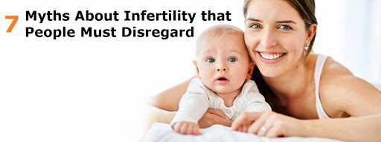

|  |
| --- |
| **distraught** |

*agitated with doubt or mental conflict or pain*  
*extremely worried, nervous, or upset:*  
The missing child's distraught parents made an emotional appeal for information on TV.  
Of particular concern are phony contractors, who knock on the doors of distraught homeowners and offer to repair damaged roofs or remove fallen trees.

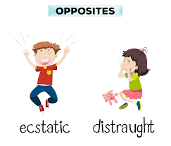

|  |
| --- |
| **district** |

There are few schools in the rural districts of Bangladesh.  
He works in San Francisco’s financial district.  
The bomb exploded in a crowded shopping district.

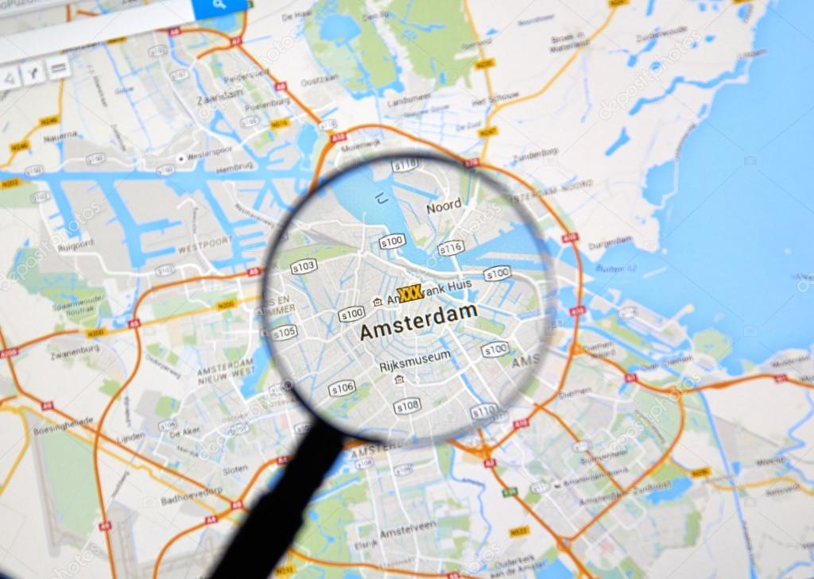

|  |
| --- |
| **divest** |

***to sell an asset, a business, or part of a business, or to reduce the amount of investment in something:***  
The company will be divesting some assets that no longer fit its profile.  
We have made a decision to divest from the hotel and casinos business to focus more on drinks sales.  
The company is divesting its less profitable business operations.

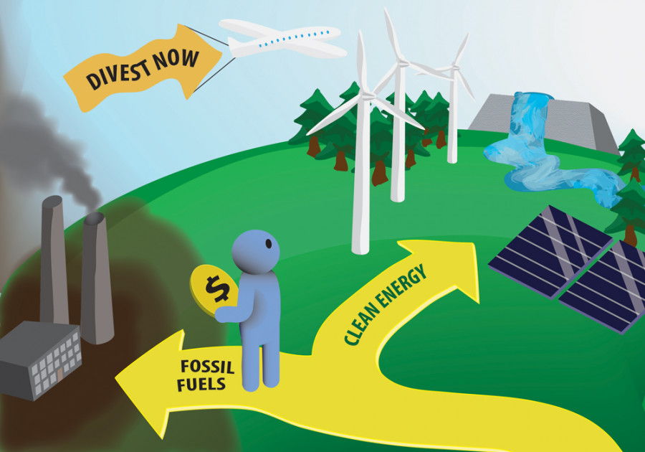

|  |
| --- |
| **divestment** |

another word for **disinvestment**  
***the act of selling off a business or businesses, or of no longer investing money in something:***  
a campaign to encourage divestment from fossil fuels

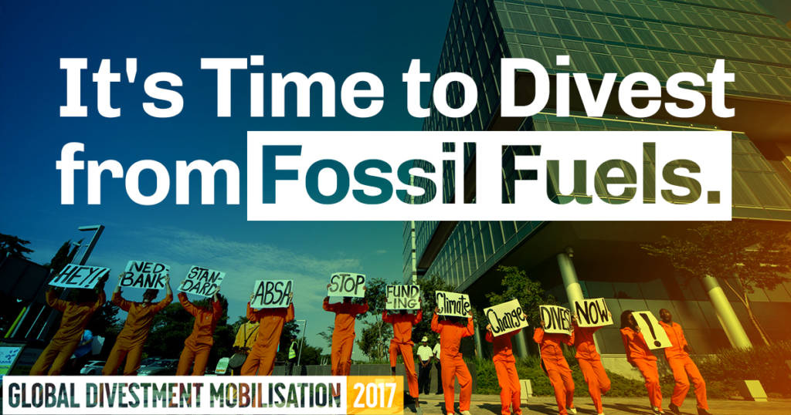

|  |
| --- |
| **dominate** |

He refuses to let others speak and dominates every meeting.  
They work as a group - no one person is allowed to dominate.  
It's astonishing to think that only a few years ago Communism dominated eastern Europe.  
It was the story that dominated the headlines this week.



|  |
| --- |
| **donation** |

He made a large donation to Cancer Research.  
Please help our campaign by sending a donation to Friends of the Earth.  
The party received a £100,000 donation from a local businessman.  
She made generous donations to various charities.  
The charity confirmed it had received an anonymous donation of £100,000.



|  |
| --- |
| **dove** |

***a white or grey bird, often used as a symbol of peace***

***someone in politics who prefers peace and discussion to war***



|  |
| --- |
| **downplay** |

***to make something seem less important than it really is***  
Grandma downplays the seriousness of her health problems.  
The government has been trying to downplay the crisis.

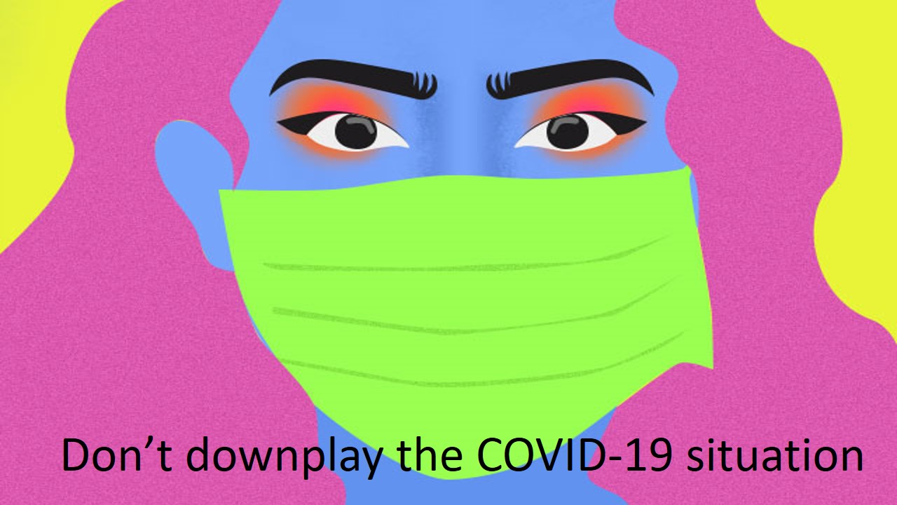

|  |
| --- |
| **dozen** |

The number of deaths has risen to more than two dozen.  
Dozens of people were killed.  
We collected dozens and dozens of shells on the beach.  
She’s had dozens of boyfriends.



|  |
| --- |
| **draft** |

I read the first draft and thought it was very good.  
The second draft of the agreement contained a few important changes.  
Could you let me see a rough draft of your report?  
He showed me the final draft of his letter.

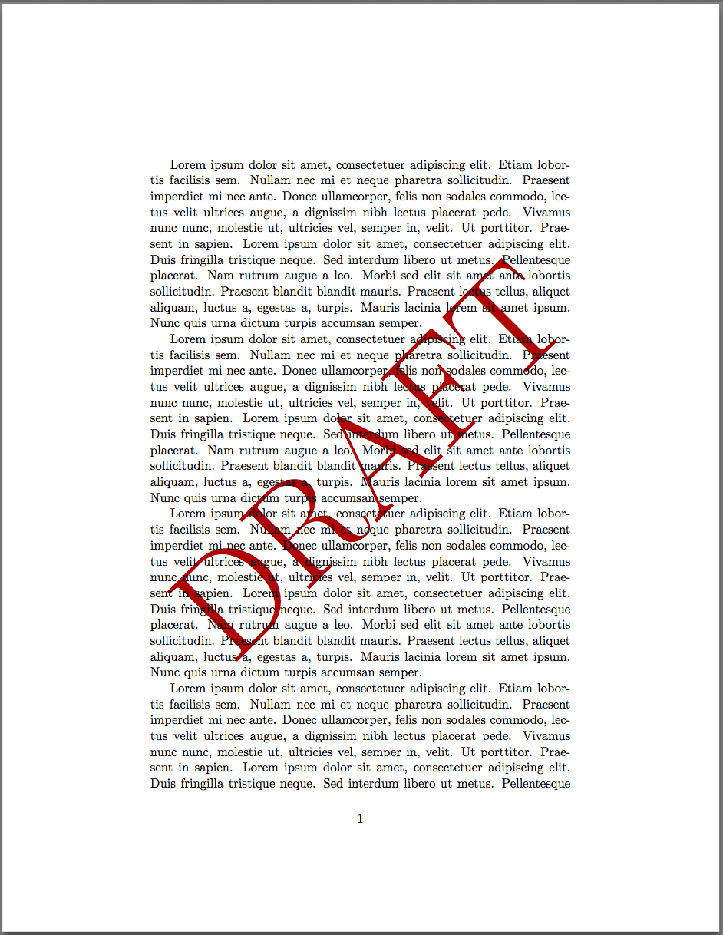

(UK **draught**)  
***a current of unpleasantly cold air blowing through a room***

Could you close the window? There's a draft in here.



|  |
| --- |
| **E** |

|  |
| --- |
| **Eastern (Standard) Time** |

**the time on the eastern coast of the United States and Canada:**  
For all major US stock markets, after-hours trading is 16:00 - 18:30 Eastern Standard Time

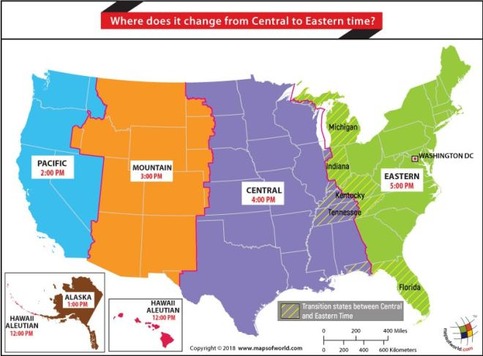

|  |
| --- |
| **endanger** |

He would never do anything to endanger the lives of his children.  
We must be careful not to do anything that might endanger the economic recovery.  
Revealing that information might endanger our national security.

|  |
| --- |
| **entangle** |

The dolphin had become entangled in/with the fishing nets.  
Mr. Kalnins is lying in bed, entangled in the covers.  
He went to the shop to buy bread and got entangled in/with (involved) a carnival parade.  
The mayor and the city council are anxious to avoid getting entangled in the controversy.



|  |
| --- |
| **entrenched** |

***Entrenched ideas are so fixed or have existed for so long that they cannot be changed:***  
It's very difficult to change attitudes that have become so deeply entrenched over the years.  
The organization was often criticized for being too entrenched in its views.

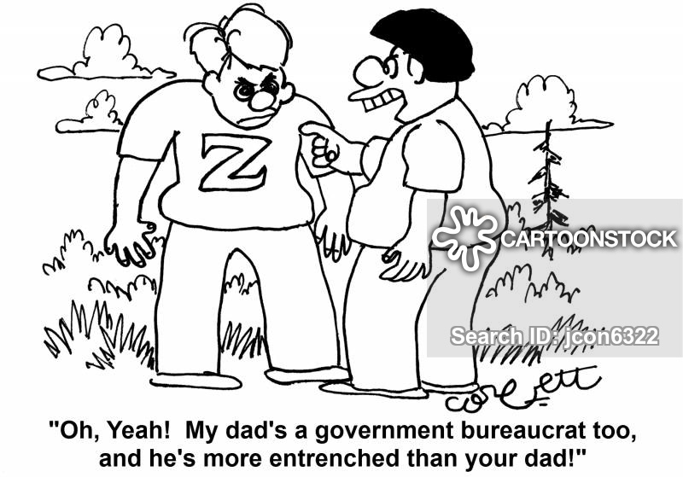

|  |
| --- |
| **epicenter** |

***the point on the earth's surface directly above the origin of an earthquake:***  
The Great Nicobar islands lie at the closest point to the epicenter of the earthquake.

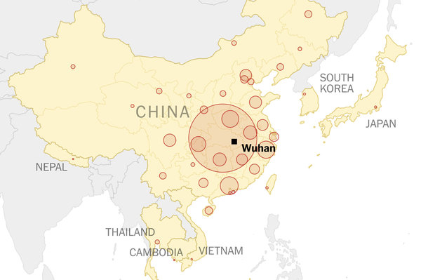

***An epicenter is also the place that has the highest level of an activity:***  
The U.S. cannot simply assume that it will remain the epicenter of scientific research and technological innovation.

|  |
| --- |
| **escalate** |

***to become or make something become greater or more serious:***  
His financial problems escalated after he became unemployed.  
Sending in more troops would escalate the  
The escalating rate of inflation will almost certainly bring escalating prices.  
You might need to escalate the issue to the next highest level management team.

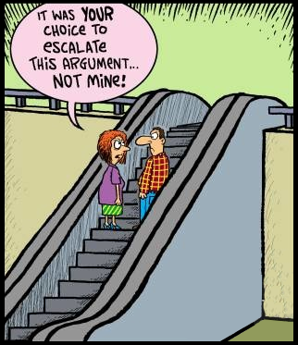

|  |
| --- |
| **euthanasia /yutenezya/** |

***Euthanasia is the practice of killing someone who is very ill and will never get better in order to end their suffering, usually done at their request or with their consent.***

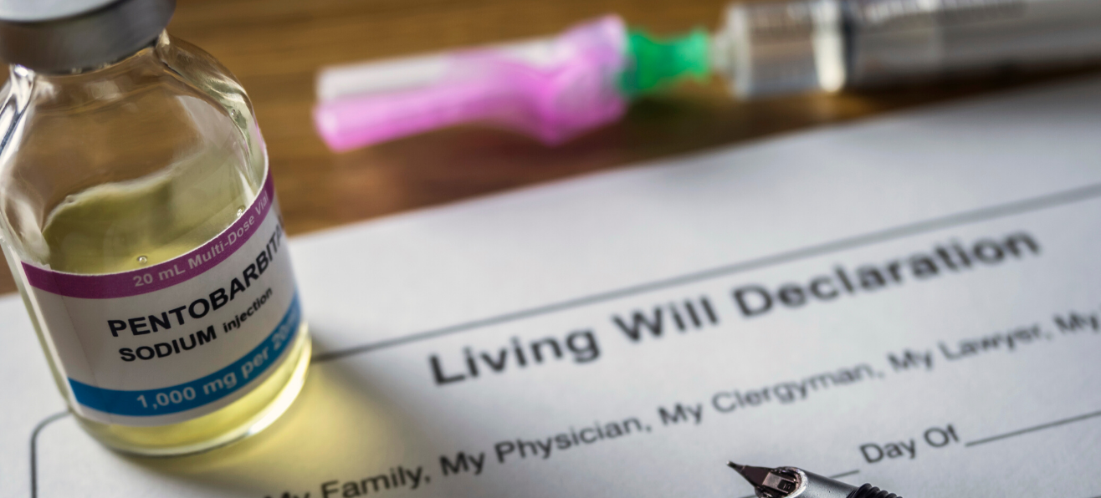

|  |
| --- |
| **eventually** |

***in the end, especially after a long time or a lot of effort, problems, etc.:***